**How to change the Demand Limits with PecStar**

Project: AUO Crystal Date: 2013/11/25

Note: Due to business development, since April 10th, 2017, Ceiec Electric Technology Inc. has been renamed to CET Electric Technology Inc., however, the products (including hardware and software) that were manufactured before this date may still involve old name or logo.

How to setup Alarm Limits with PecConfig

The alarm rule is a setpoint condition for a real-time source. The PecView is used to monitor the real-time vaules of the system, when an alarm rule is met, a real-time event will be generated and pushed up in the event window of HMI.

Follow the procedures to setup an alarm rule with PecConfig:

1. Click the  icon – PecAssistant from the Windows taskbar.

2. Click the PecConfig button to start the system configuration program.

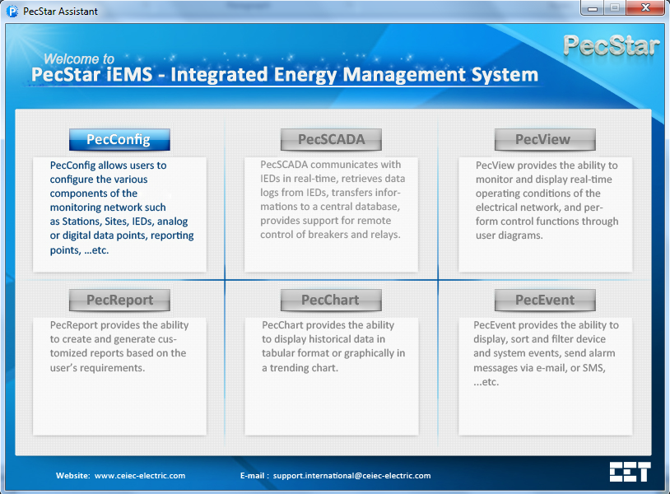

3. Click the  icon in front of **Station Setup** and **Station 1** on the left-hand pane to expand the tree. Then click on the **Alarm Rule Setup** folder. All alarm rules are displayed on the right-hand pane. Select the alarm rule you want to modify, and click the  icon from the tool bar.

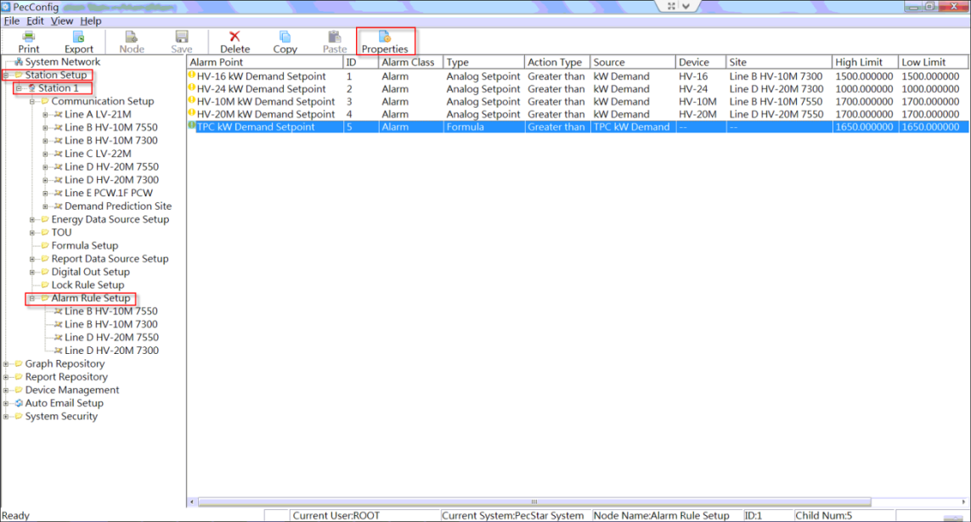

4. The Alarm Condition Properties window appears. Set the **High Limit**, **Low Limit**, **Action Delay(s)** and **Return Delay(s)** as required.

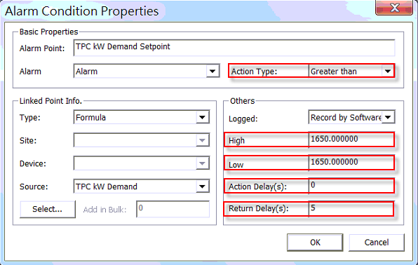

**Eval Mode:** The Eval Mode specifies the criterion by which the source is evaluated. The options contain Less than and Greater than.

**High Limit:** When the Eval Mode is Greater than, the High Limit specifies what limit the source must exceed for an alarm to turn on. When the Eval Mode is Less than, the High Limit specifies what limit the source must exceed for an alarm to turn off.

**Low Limit:** When the Eval Mode is Greater than, the Low Limit specifies what limit the source must fall below for an alarm to turn off. When the Eval Mode is Less than, the Low Limit specifies what limit the source must fall below for an alarm to turn on.

The High Limit must be higher than or equal to the Low Limit.

**Action Delay(s):** When the Eval Mode is Greater than, the Action Delay(s) specifies the amount of time in seconds the source must exceed the High Limit for an alarm to turn on. When the Eval Mode is Lower than, the Action Delay(s) specifies the amount of time in seconds the source must fall below the Low Limit for an alarm to turn on.

**Return Delay(s):** When the Eval Mode is Greater than, the Return Delay(s) specifies the amount of time in seconds the source must fall below the Low Limit for an alarm to turn off. When the Eval Mode is Lower than, the Return Delay(s) specifies the amount of time in seconds the source must exceed the High Limit for an alarm to turn off.

Current Settings:

If TPC kW Demand is greater than 1650kW, a real-time event will be generated and pushed up.

5. Click the  icon in front of **Demand Prediction Site** on the left-hand pane to expand the tree. Right-click **Demand Prediction Feeder** and select **Properties** from the pop-up menus.

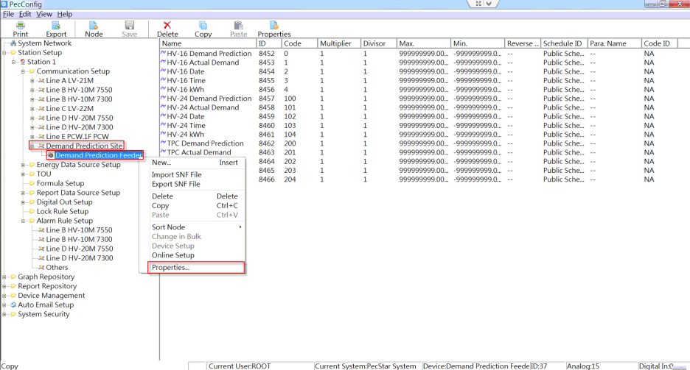

6. The **Device Properties** window appears. Click **INF File>>**.

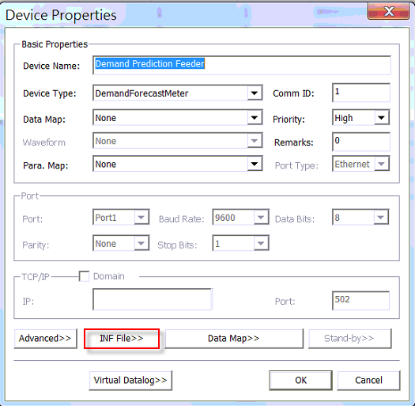

8. The **Edit Text File** window appears. Change **LimitValue** highlighted in the red boxes if required and click **OK**.

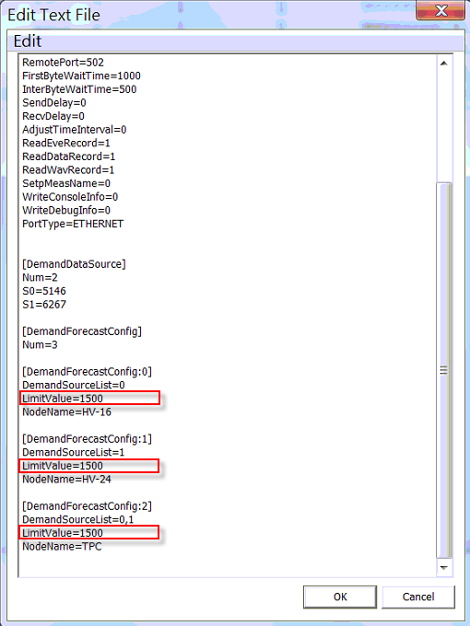

8. Click the **Save** icon  from the tool bar. The **System Config** information box appears, click **OK**.

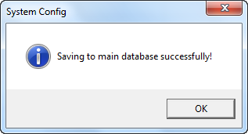

8. Restart the **Front** and **PecDemandForecast** from Start🡪Programs.



PecDemandForecast.exe

Front.exe

How to setup Alarm Limits with PecDraw

The user diagrams are created with PecDraw and displayed with PecView. In the “AUO Energy&Demand” diagram, the following objects have properties relative to the demand limit.

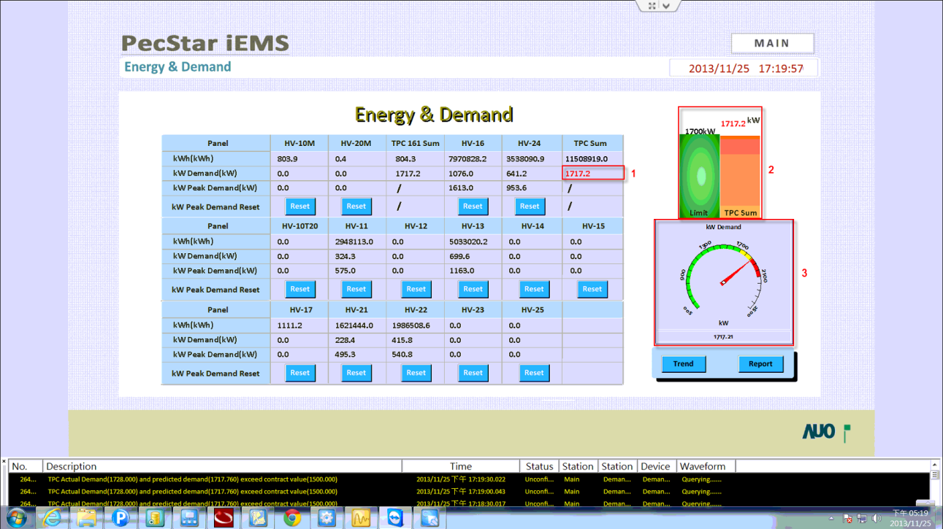

Follow the procedures to change the demand limit with PecDraw:

1. Click Windows Start 🡪 All Programs 🡪 PecStar V3.5 🡪 Client Workstation Module 🡪 PecDraw to start the program.

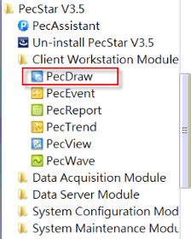

2. The Login window appears. Enter the correct user name and password. By default, User Name: ROOT, no password. Click **OK**.

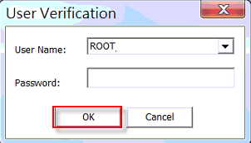

3. Click the **Open** icon  from the tool bar. The **Open** window appears. Select the **“AUO Energy&Demand.drw”** file under the **Graph** folder and click **Open**.

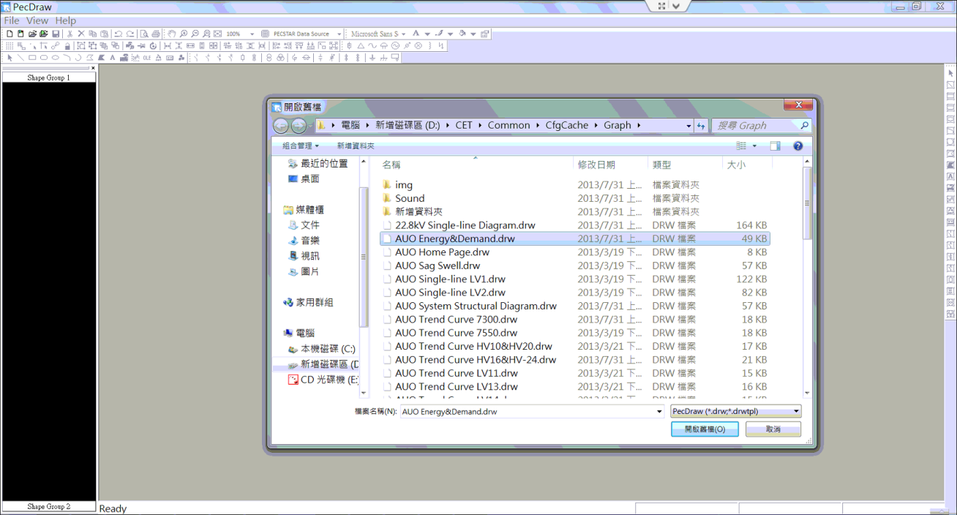

4. The **“AUO Energy&Demand.drw”** file is open.

For the table(1):

Right-click on the object of TPC Sum kW Demand and select **Properties…** from the pop-up window.

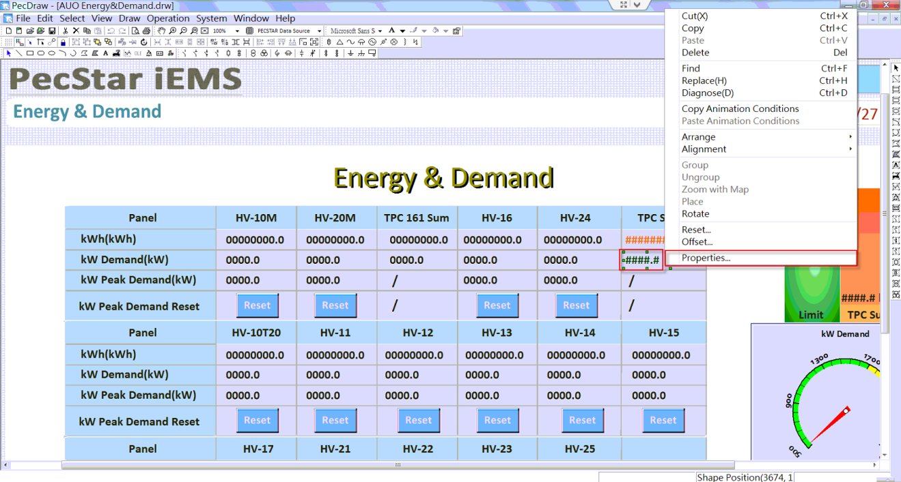

5. The **Shape Properties** window appears. Navigate to the **Normal Animation** tab, click on the **Define…** button under **Color Animation**.

The **Color Animation List** window appears.

Select the first condition from the **Animation Condition** list and click **Modify**.

The **Color Animation** window appears. Enter the **Min** and **Max** value and click **OK**. If the source value is in the range of **[Min, Max]**, the text object will be displayed in the color defined by **Animation Result**.

Select the second condition from the **Animation Condition** list and click **Modify**. Enter the **Min** and **Max** value and click **OK**.

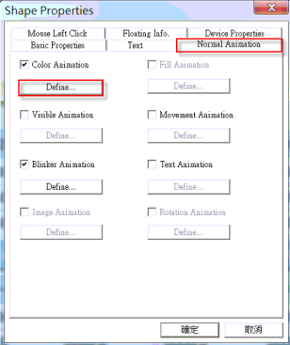 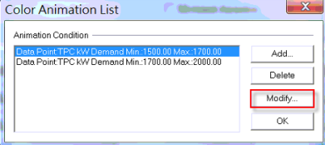 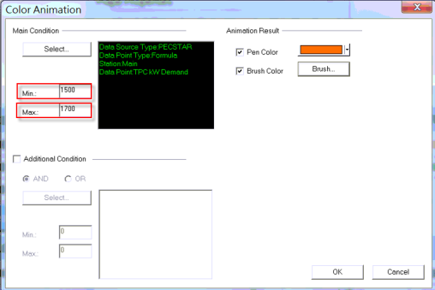

Click **Close** to close the **Color Animation List** window.

Current Settings:

If kW Demand is in the range of [1500, 1700], the value will be displayed in Orange.

If kW Demand is in the range of [1700, 2000], the value will be displayed in Red.

Click on the **Define…** button under **Blinker Animation**.

The **Blinker Animation** window appears.

Select the condition from the **Animation Condition** list and click **Modify**.

The **Blinker Animation** window appears. Enter the **Min** and **Max** value and click **OK**. If the source value is in the range of **[Min, Max]**, the text object will blink as an alarm to attract the attention of the operator.

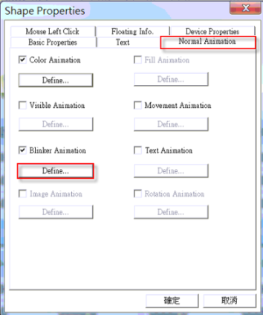 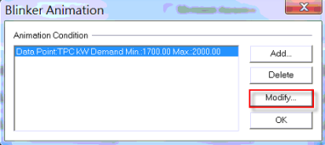 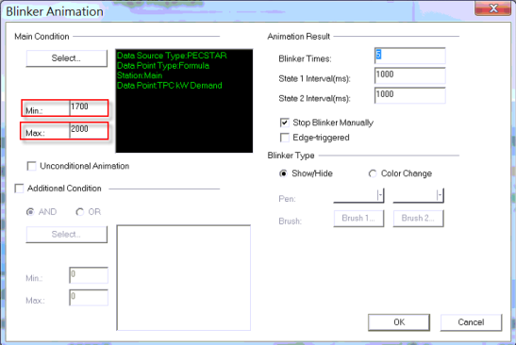

Click **Close** to close the **Blinker Animation** window.

Click **Ok** and then close the **Shape Properties** window.

Current Settings:

If kW Demand is in the range of [1700, 2000], the value will blink.

For the bar (2):

6. Double-click on the object of **1000kW** and the **Shape Properties** window appears.

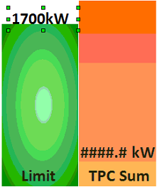 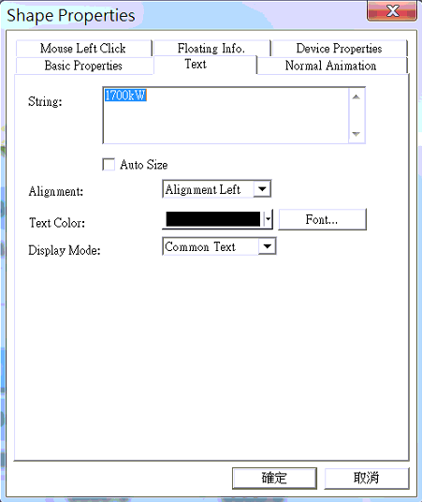

Change the Text **1700kW** to the new demand limit in the **Text** tab.

7. Double-click on the object of **####.#** and the **Shape Properties** window appears. Navigate to the **Normal Animation** tab, click on the **Define…** button under **Color Animation**, **Movement**, and **Blinker Animation** with check box. Change the limit from pop-up window as step 5.

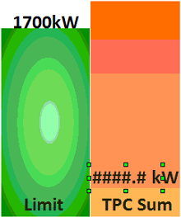 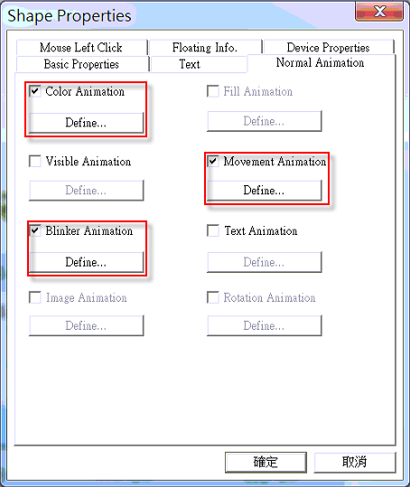 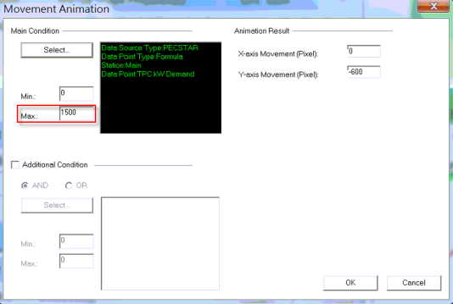

Change the properties for the objects of **kW** and the rectangle on the right in the same method.

For the dial (3):

8. Double-click on the dial object and the **Shape Properties** window appears. Navigate to the **Special Properties** tab, click on the **Settings…** button behind **Coordinates**.

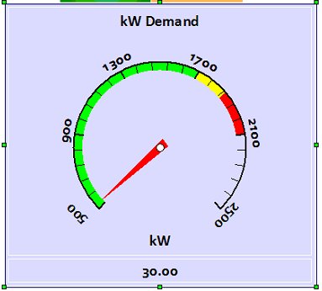 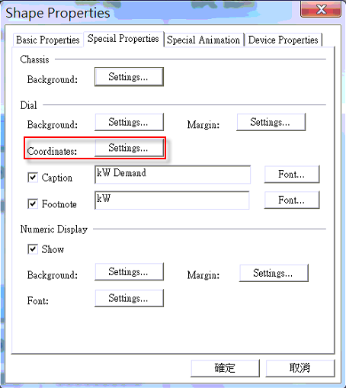

The **Dial** window appears. Set the **Start** and **End** value of **Filling 1**, **Filling 2**, and **Filling 3**.

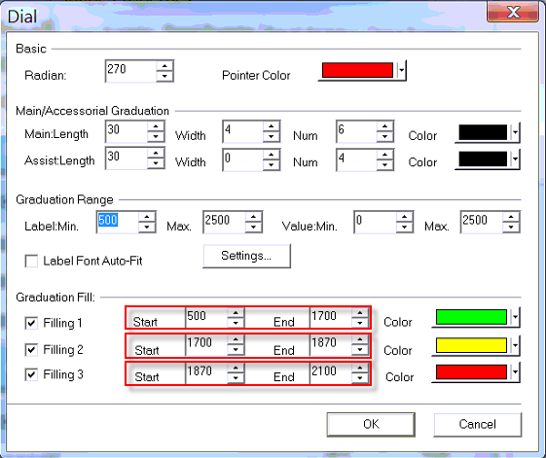

Click Ok to return to main window.

9. Click on the **Save** icon on the tool bar in PecDraw to save the diagram to local cache.

10. Click **File** from the menu bar and select **Upload Graph Repository**.

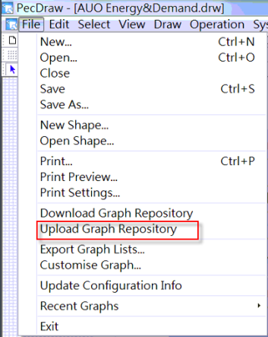  
The **Confirm Upload** dialog box appears. Click **Ok** to continue. Then the updated diagrams are saved to the database.

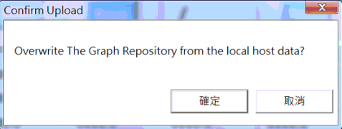

How to update the diagrams in PecView

1. Start PecView.

2. Right-click on the window and click **Show/Hide Toolbar** from the pop-up menus. 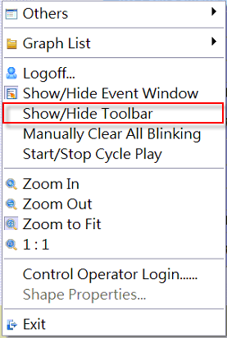

3. Click on the **PecStar** button at the left bottom of PecView and select **Update Graph🡪All Graphs**. If the diagrams are modified with PecDraw, the diagrams displayed in PecView will be updated.

